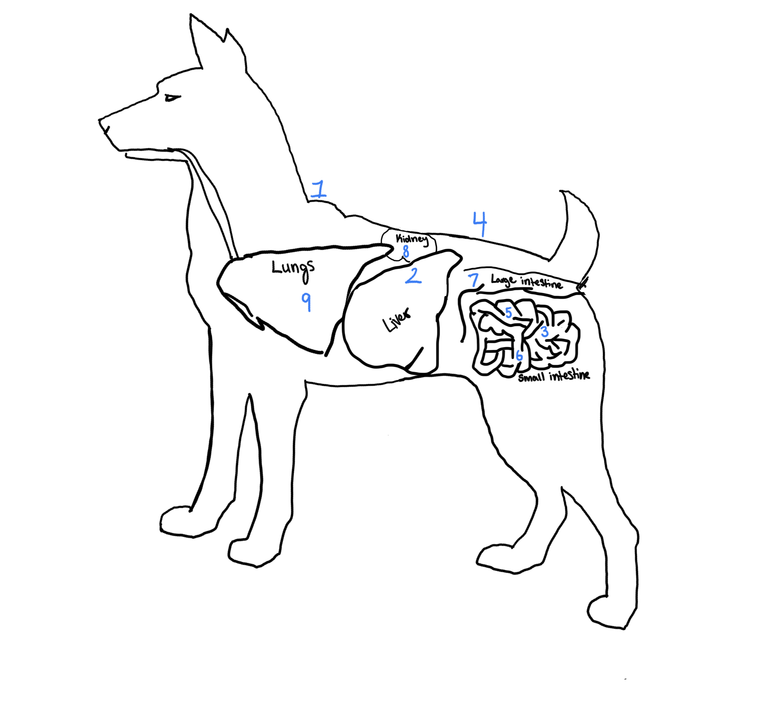

The picture above indicates the locations where 9 adult parasites live in the dog. Below are the lifecycles associated with each numbered location, as well as some information about that parasite. Please match the names of parasites to their appropriate lifecycle and location on the dog. In this activity two parasites live on the surface of the dog, three live in the small intestines, one in the large intestines, one in the lungs/airways, one in the liver, and one in the kidneys.

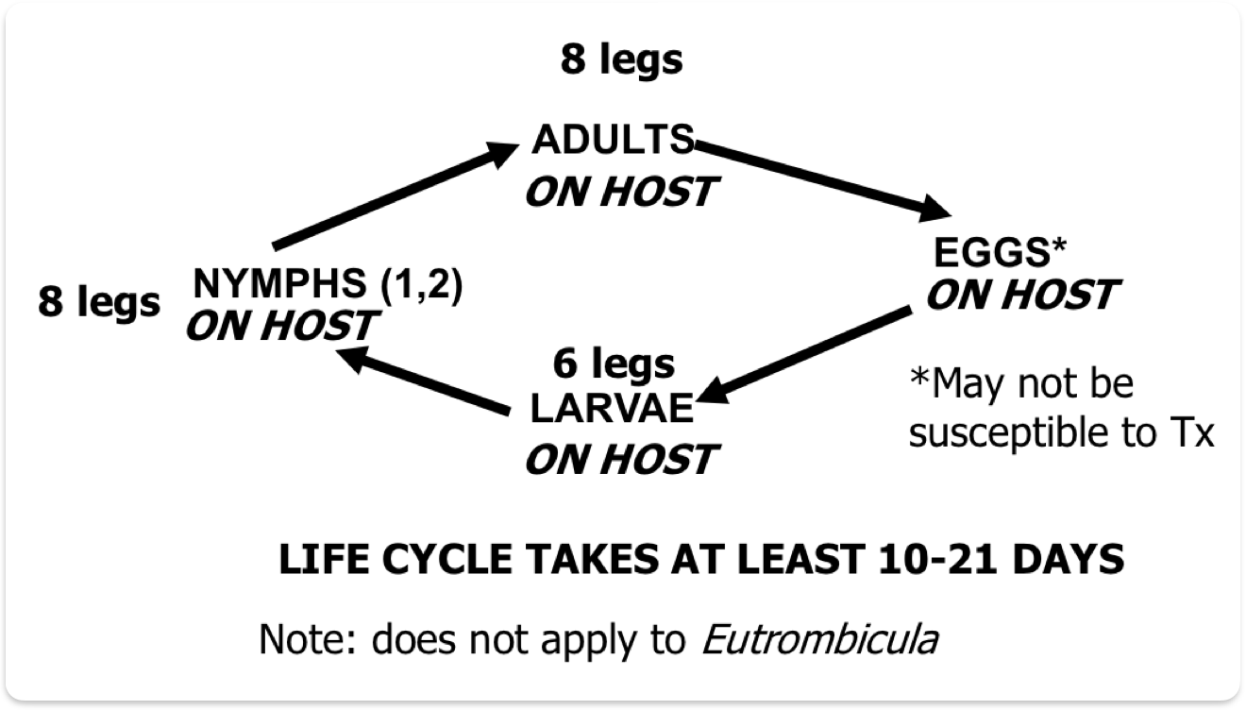
1
This parasite is highly contagious between dogs.
May cause mild symptoms in people which self resolve.
Cause intense itchiness, redness, hair loss and crusting.
Treat with isoxazolines or ivermectins
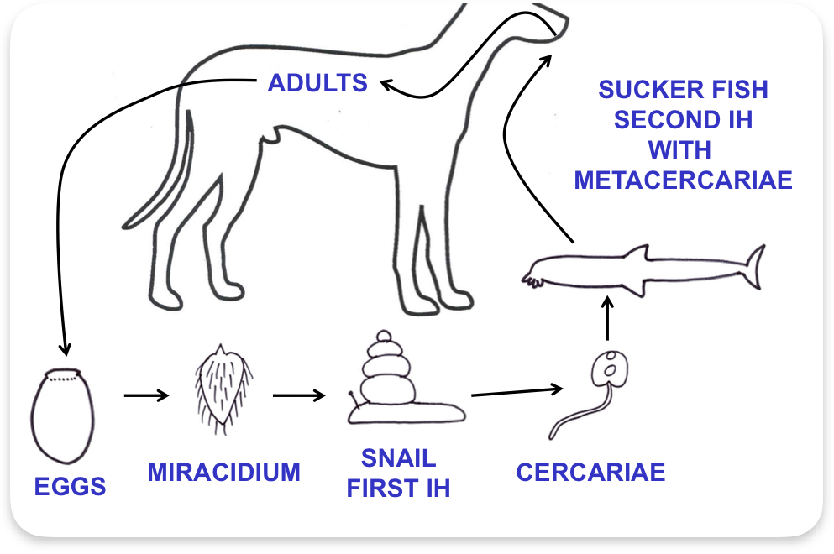
2
Common in rural and remote areas.
Can infect people however not transmitted to people from dogs.
Usually no clinical signs noted with infection
Treated with praziquantel
Prevent infection by not feeding raw fish to dogs

3
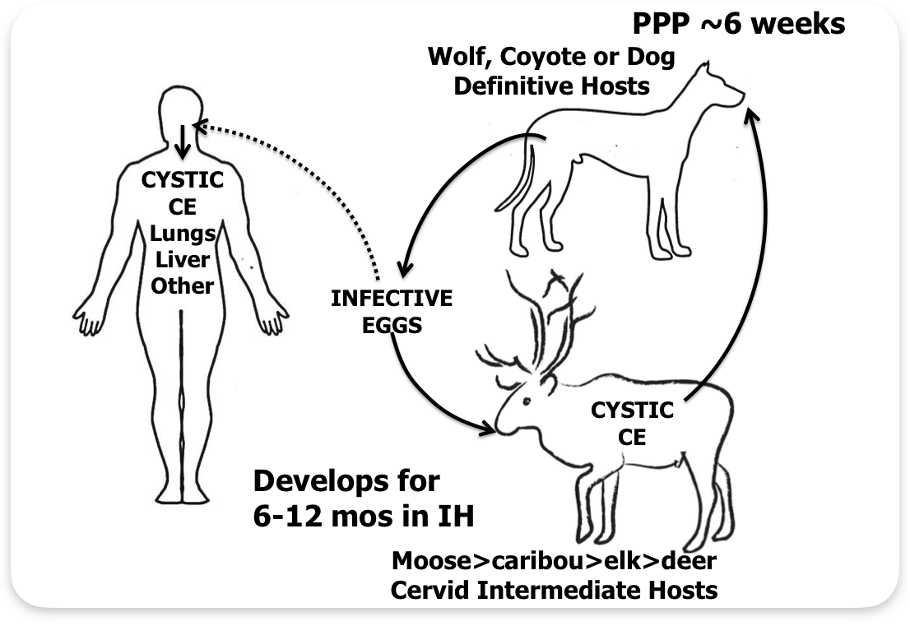
Seen across Canada, more common in older dogs.
Dogs can infect humans and cause severe cystic lesions.
Few symptoms seen in infected dogs.
Treat with praziquantel if the animal has access to cervid carcasses.
Prevent dog access to raw cervid carcasses.
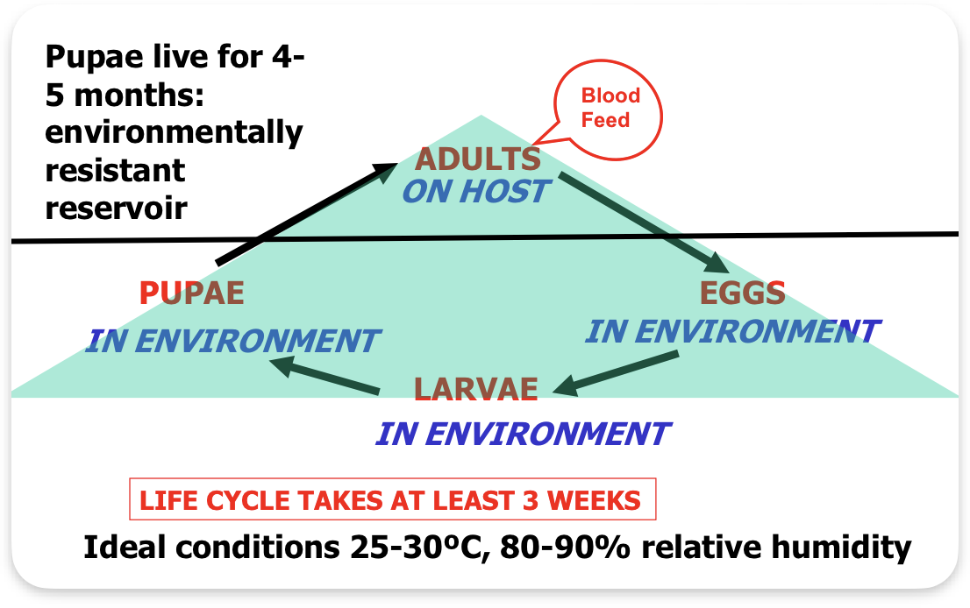
4
Contagious through infected environment.
May bite people but not preferred.
Causes anemia, dermatitis, hair loss, and can transmit bacterial infections and other parasites to their hosts.
May see this parasite directly on the animal.
Treats with imidacloprid and clean the environment.
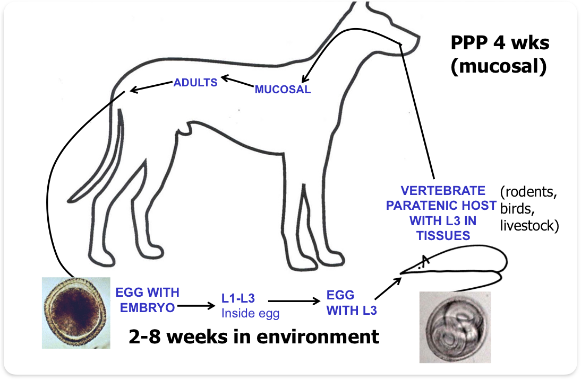
5
The most common parasite in Canada.
People may be accidental hosts and be infected in their liver, lungs, eyes, or brain.
Eggs can survive for years in the environment.
Clinical signs seen in puppies include pot belly, poor coat, diarrhea, respiratory issues, seizures and death.
Infected females may shed larvae into her milk.
Treat with fenbendazole, moxidectin, or pyrantel pamoate.

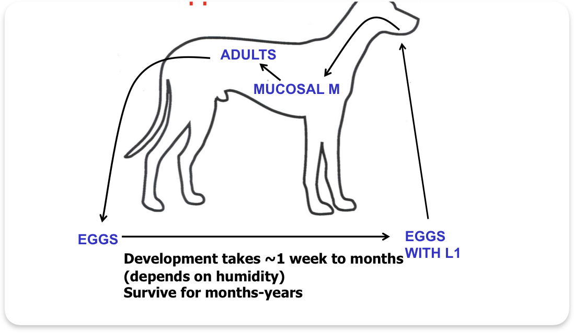
6
Found worldwide, spread to dogs from eggs in the environment.
Does not infect people.
Symptoms include chronic bloody diarrhea and mild anemia.
Treat with benzimidazoles or macrocyclic lactones and clean environment.
Ineffective through environment or paratenic host.
Does not infect humans.
Rarely cause clinical disease, may see diarrhea and dermatitis.
Treat puppies with benzimidazoles or macrocyclic lactones.

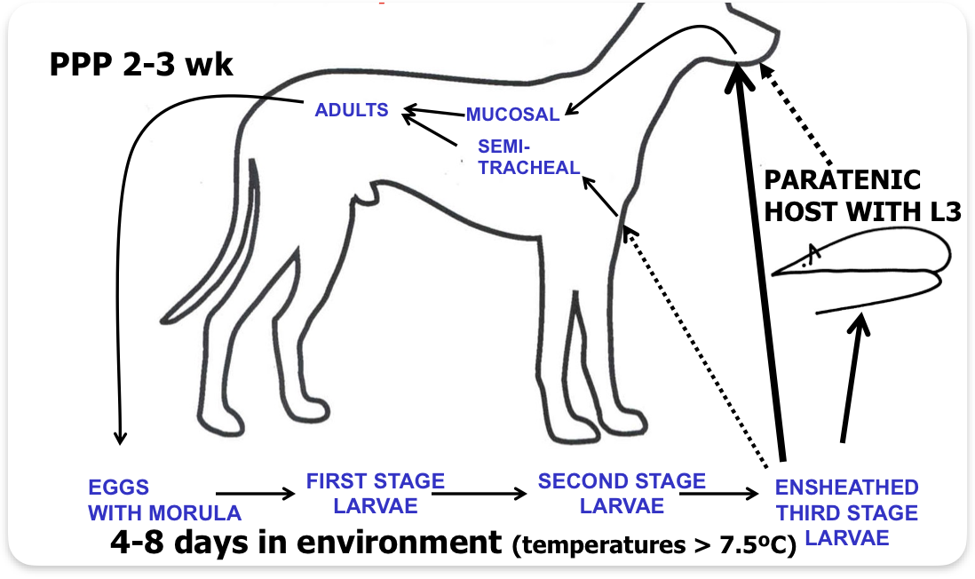
7
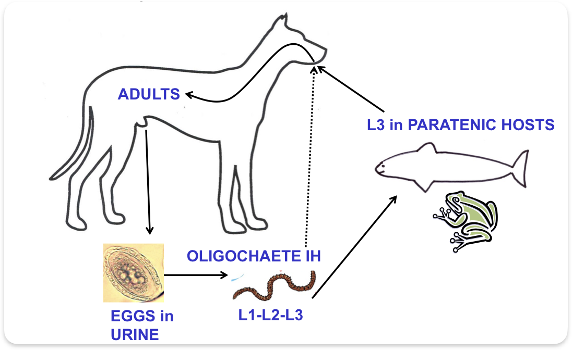
8
Most common in Manitoba and northern Ontario. Dogs infected from paratenic hosts like fish and frogs.
Rarely can infect people.
Typically does not cause clinical signs.
Uniquely favours the right side of the body and can be over 1 meter long.
Not generally treated.

9
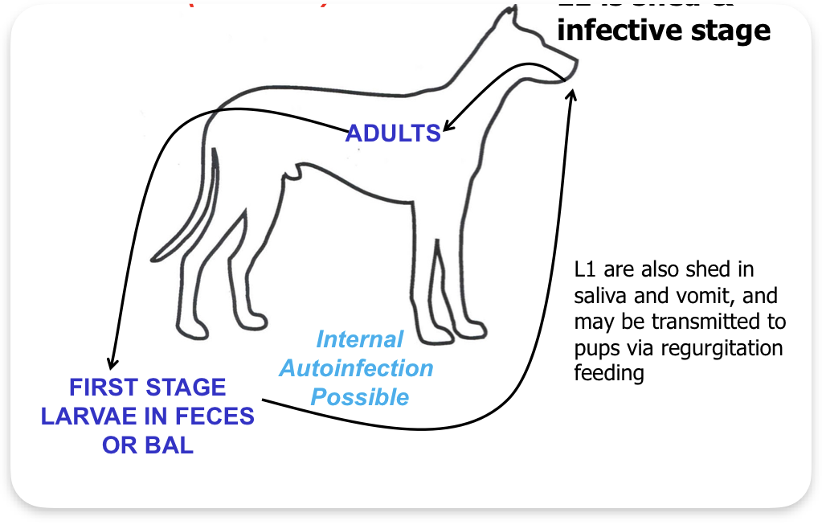
Found usually in wild dogs and dogs who hunt them. May be passed from mothers to puppies by milk, as well as from the environment.
Do not typically infect humans.
Often no clinical signs, may see coughing and retching when they exercise, or cyanosis and collapse in puppies.
Treat with macrocyclic lactones or fenbendazole, and clean environment.

Parasite key:
Metorchis Conjunctus : #__
Ctenocephalides Canis: #__
Sarcoptes : #__
Uncinaria Stenocephala: #__
Osleru Osleri: #__
Trichuris Vulpis: #__
Dioctophyma Renale: #__
Toxocara Canis: #__
Echinococcus Canadensis: #__

Answer Key:
- Sarcoptes scabei var canis
- Metorchis Conjunctus
- Echinococcus Canadensis
- Ctenocephalides Canis
- Toxocara Canis
- Uncinaria Stenocephala
- Trichuris Vulpis
- Dioctophyma Renale
- Oslerus Osleri

Resources for teachers:

WCVM learn about parasites: https://wcvm.usask.ca/learnaboutparasites/index.php

Veterinary Partner, Infections: Bacteria, Fungi, Viruses, Parasites:
https://veterinarypartner.vin.com/default.aspx?pid=19239&catId=254096&ind=299

Citations

Infections: Bacteria, fungi, viruses, parasites - veterinary partner. VIN. (n.d.). https://veterinarypartner.vin.com/default.aspx?pid=19239&catId=254096&ind=299

Learn about parasites - learn about parasites - western college of veterinary medicine. wcvm. (2006). https://wcvm.usask.ca/learnaboutparasites/index.php

This activity is aimed at biology 30 level students and fits into the curriculum section BI30-OL2: compare the anatomies, physiologies, and behaviours of multicellular organisms including protists, fungi, plants and animals. Section h) compare how multicellular organisms acquire, transport, and excrete materials intraorganismally, and interorganismally, including through symbiotic relationships (e.g., mutualism, commensalism, and parasitism).

