Lesson Plan:

Major Learning Points

- Students should learn the different types of canine/feline teeth along with the purpose of each tooth.

Incisors | Small teeth at the front of the mouth that are used for scraping and grooming.
Canines | Long pointed teeth that are used for tearing food. These teeth are also important in holding in the tongue.
Premolars | Sharp-edged teeth that are used to chew and shred food.
Molars | Furthest back teeth that are used to breakdown hard foods.

- The activity sheet should be completed in small groups so that students can discuss what they think the purpose of each tooth type is. After groups have completed the table, the answers can be discussed with the whole class.

- Students should learn how to care for their pet’s teeth at home and why this is important.

- Things that can be done at home for dental care:
  - Brushing their teeth
    - This should be done with pet-specific toothpaste.
    - Ideally done every night, but a few times per week is still beneficial.
  - Dental treats and chews
    - Products with the Veterinary Oral Health Council (VOHC) seal of approval are supported by veterinarians.
  - Diet
    - Dental formulations can help clean their teeth.
  - Avoid bones
    - These can cause fractures!
  - Oral rinses and additives
    - Additives can be added to water

Crossword answers:

 |  |  |  |  |  |  | ⁶ B
 |  |  |  |  |  |  | R
 |  |  | ¹ T |  |  |  | O
 |  |  | R |  |  |  | K
 |  |  | U |  |  |  | E
³ I | N | F | E | C | ² I | O | N
 |  |  |  |  | N
 |  |  |  |  | C
 |  |  |  |  | I
 |  |  |  |  | S
 |  |  | ⁴ B | L | O | O | ⁵ D
 |  |  | O |  | R |  | O
 |  |  | N |  | S |  | ⁶ G | U | M
 |  |  | E |  |  |  | S
 | ⁷Y | E | S

- Students should learn the different severities of dental disease

- Go through the different severities with students and discuss what each stage means. If students have pets at home, have them look at their own pets’ teeth and have them decide what grade they would give to their pet.
Activity One: Canine Teeth

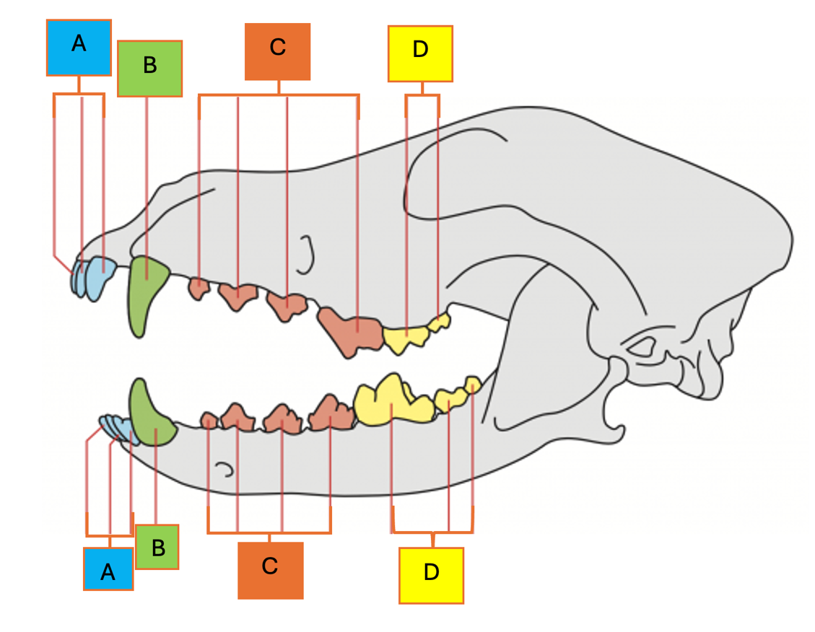
Identify the types of teeth and think of some reasons why these teeth are important:
Options:
- Premolars
- Canines
- Molars
- Incisors

 | Tooth type | Use/Importance
A
B
C
D
Activity Two: At-Home Dental Care

Think of some ways in which you could care for your pet’s teeth at home:

Fill out the following crossword related to dentistry and dental disease:
Across

3 | Dental disease can weaken the body’s immune system and lead to a higher risk of ______
4 | Bacteria from dental disease can enter the _________ and affect organs such as the heart, liver, and kidneys
6 | Gingivitis is inflammation/swelling of the _________
7 | Is dental disease painful? Yes or no
Down

1 | Diseases in the mouth can increase the risk of heart problems – true or false
2 | _______ are the small teeth at the front of the mouth
4 | This type of dog treat is very hard and can cause broken teeth
5 | Which animal has more teeth? Dogs or cats
6 | Dental disease may result in a ______ jaw

 |  |  |  |  |  |  | ⁶
 |  |  | ¹
³ |  |  |  |  | ²
 |  |  | ⁴ |  |  |  | ⁵
 |  |  |  |  |  |  | ⁶
 | ⁷

Activity Three: Dental Disease
Stages of Dental Disease:
* Tip! Periodontitis is what veterinarians use to refer to infection of the gums
Stage 1:  Gingivitis | Gums are swollen and inflamed. Some plaque is visible. These teeth are easy to clean! | 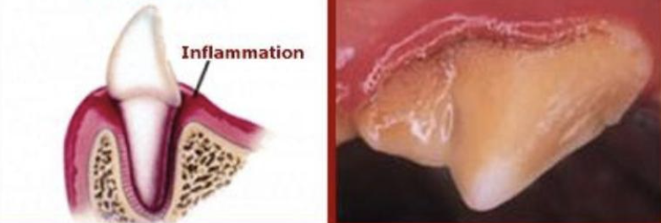
Stage 2:  Early periodontitis | Gums are swollen and inflamed. The mouth is painful and may have a bad odor. These teeth can be cleaned with at home and veterinary care. | 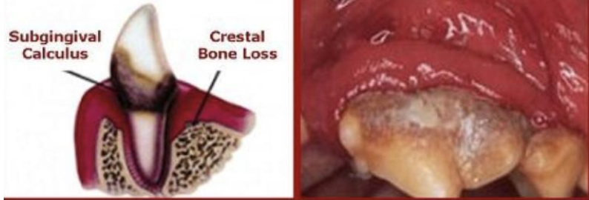
Stage 3:  Moderate periodontitis | Gums may be bleeding or destroyed. The mouth is sore and animals may avoid eating. | 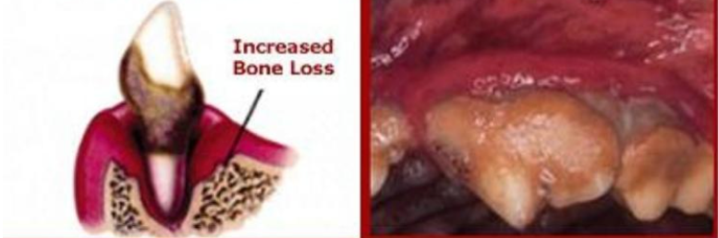
Stage 4:  Advanced periodontitis | Bacteria destroy the gums, tooth, and bone. These infections may spread throughout the whole body and affect other organs. | 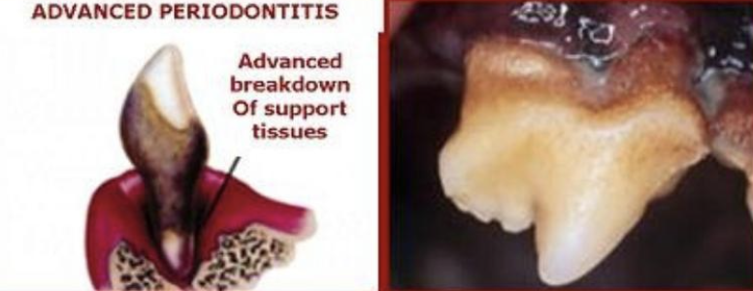

Reference Websites:
Types of dog teeth: https://www.purina.co.uk/articles/dogs/health/dental/canine-dental-anatomy
Oral hygiene tips: https://www.petmd.com/dog/general-health/dog-dental-care-6-ways-keep-dogs-mouth-clean
Dental disease: http://commonwealthanimalhospital.net/dental-health-and-dental-care/example-pictures-of-dental-disease.html; https://www.abvc.ae/blog/dog-periodontal-disease/

